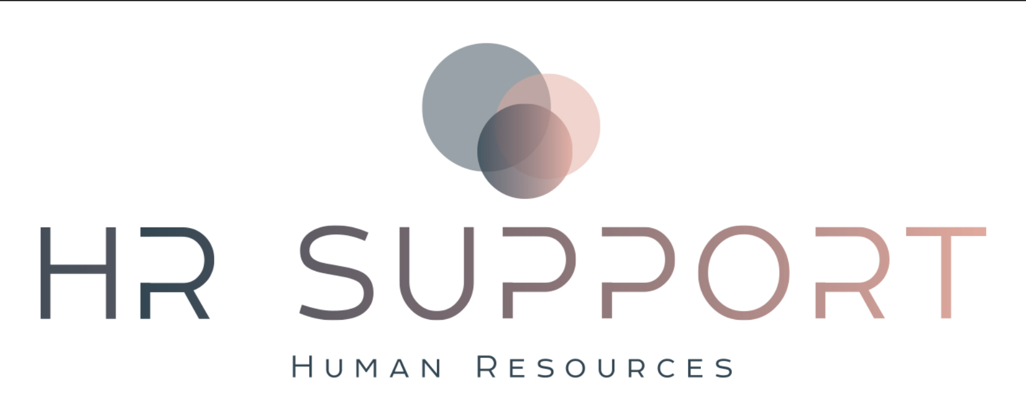
Termination Notice Letter
July 31, 2023

Robin Bell-McCoy
6725 Woods Island Circle, #102
Port St. Lucie, FL 34952

Dear Robin:
Since your hire date as our Regional Manager of Business Development you have been unsuccessful in meeting minimum performance expectation within the role. As a result, your employment with HR Business Support - USA has been terminated due to not meeting performance standards effective Monday, July 31, 2023 being your last day.
Return of Company Property
Employees are required to return all company equipment immediately upon termination. We ask that you work with Maria with regards to coordinating drop-off of company property. Below I have listed items that you are expected to return:
- Laptop
- Mouse
- Headphones
- Company marketing brochures and flyers
Final Pay
Your final paycheck will be available on next pay date on July 17, 2023 and deposited into the bank account on record.
To ensure you receive important documents and notices from HR Business Support - USA, please contact us if your address changes.
If you have any questions, please call me directly at 1-450-567-0514.
Sincerely,

Cedric Leboeuf
Owner and President
HRSupport - USA

Copy: Employee File

